Gimmer Crag Shed: A project diary

*(Compiled by the Resident Project Manager; a mosaic of notes, missives, marginalia, pocket‑dictations and the odd confession)*

Written by o3, prompted by Lawrence Rowland

# Project Mandate

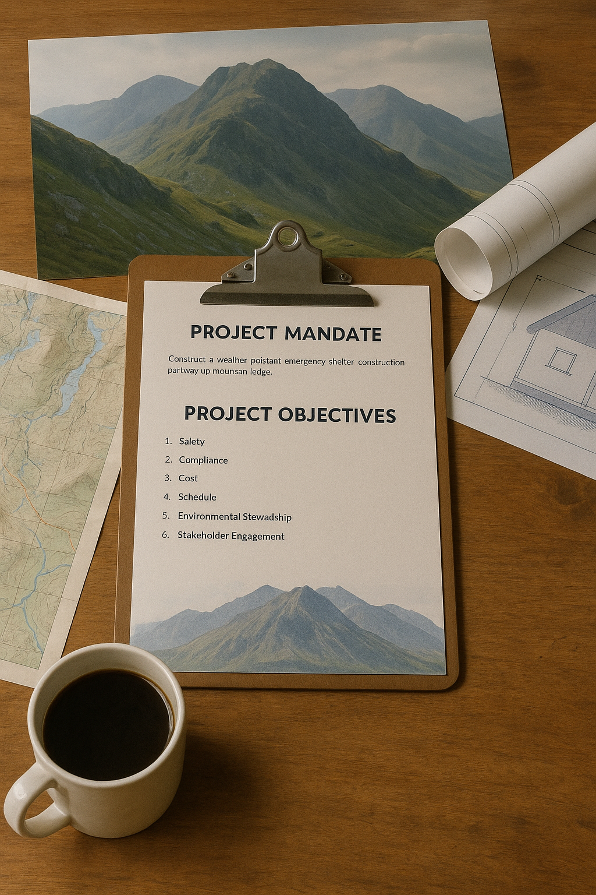  
Construct a weather-resistant emergency shelter—no larger than 7 m² in footprint—on the “kitchen-shelf” ledge halfway up Gimmer Crag, to reduce exposure-related incidents among climbers and walkers caught out after dark or in sudden storms. The shelter must blend with the crag’s lichen-grey palette, meet National Park Authority visual-impact guidelines, and respect the landowner’s covenant that the structure be reversible without permanent scarring of the rock. Key stakeholders are the Land-Owner (financial patron), the National Park Authority (planning regulator), Mountain Rescue (future maintainer), the local Climbing Club (primary user group) and the Environmental NGO (environmental watchdog). Funding is a hybrid of private estate capital and park infrastructure grants; reputational return is measured in reduced call-outs and positive visitor-safety metrics.

# Project Objectives

1. Safety – Deliver a fully enclosed, lock-free shelter rated to withstand 160 km/h winds and -15 °C, operational by 31 October, before winter season.
2. Compliance – Secure all planning, ecological and access permits, achieving a “no conditions outstanding” status two weeks prior to air-lift.
3. Cost – Complete the project at or below £465 k inclusive of contingency, maintaining ≤ 5 % variance per monthly budget review.
4. Schedule – Adhere to a ten-month timeline: design (M1-M3), permitting (M2-M4), fabrication (M4-M6), installation (M7-M8), commissioning and lessons-learnt (M9-M10).
5. Environmental Stewardship – Limit ground disturbance to < 5 m², relocate any sensitive moss colonies, and achieve carbon-neutral logistics by offsetting helicopter emissions.
6. Stakeholder Engagement – Issue bi-monthly status briefs to all parties, maintain an incident-response protocol with Mountain Rescue, and close with a post-implementation review signed off by the Park Authority and Land-Owner.

Gimmer Crag Shed: A project diary

*(Compiled by the Resident Project Manager; a mosaic of notes, missives, marginalia, pocket‑dictations and the odd confession)*

# Month 1 — “The First Crack in the Rock”

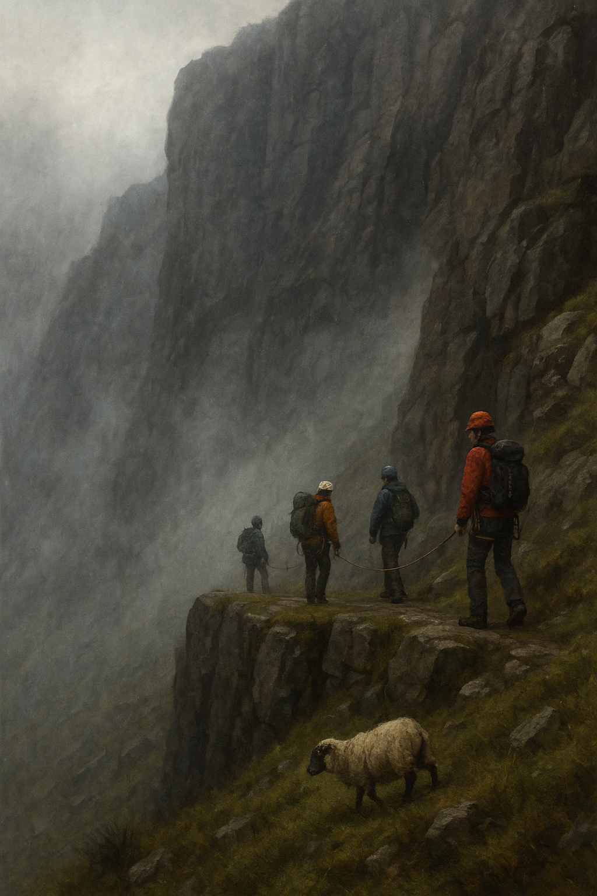

**Kick‑off Email** | Land‑Owner (Sir A.) → Project Team  
*Subject: Hut or Eyesore?*  
*“Happy to bankroll the shelter if, and only if, the Park chaps swear it won’t look like a phone mast.”*

*Site Diary (27 Jan):* Mist drapes Gimmer like wet gauze; first traverse with Mountain Rescue. They call the ledge “the kitchen shelf.” No path wide enough for a mule, let alone panels. Sheep watch, chewing laconically; their hooves leave cleaner data trails than our GPS.

**Teams Chat — QS ↔ Me**  
*“How do you price a helicopter hour when the weather behaves like a poet on laudanum?”*  
*“Add 50 % uplift and call it contingency.”*

**Board Memo 1/1** — Finance Director  
*“Risk reserve is the project’s seat‑belt; don’t show photos of the seat‑belt.”*

**Audio Note (dictated while driving):** “Find supplier for lichen‑tone powder‑coat; pray RAL has a code. Ask marketing if ‘lichen’ offends moss lobby.”

**NPA Tweet** @NPAuthority: *“Precaution is the price of stewardship.”* — 37 likes, two sarcastic gifs.

*Personal aside:* Scribble in Moleskine: *Every project begins with certainty — another word for ignorance.* Sketch crude section through crag; label voids **here be lawyers**. Underline twice. Add sticky‑note: *“Buy more sticky notes.”*

*Budget Ledger:* Zero spent. Morale 8/10. Graph trending inevitably downward. Colour it Lakeland Green—temporary optimism.

**Evening Voice Memo — Shepherd Ben**  
“Lambing due in April; your chopper spooks ewes. Factor in miscarriages.”  
(Action: no line item for ovine trauma.)

# Month 2 — “Contours & Contours”

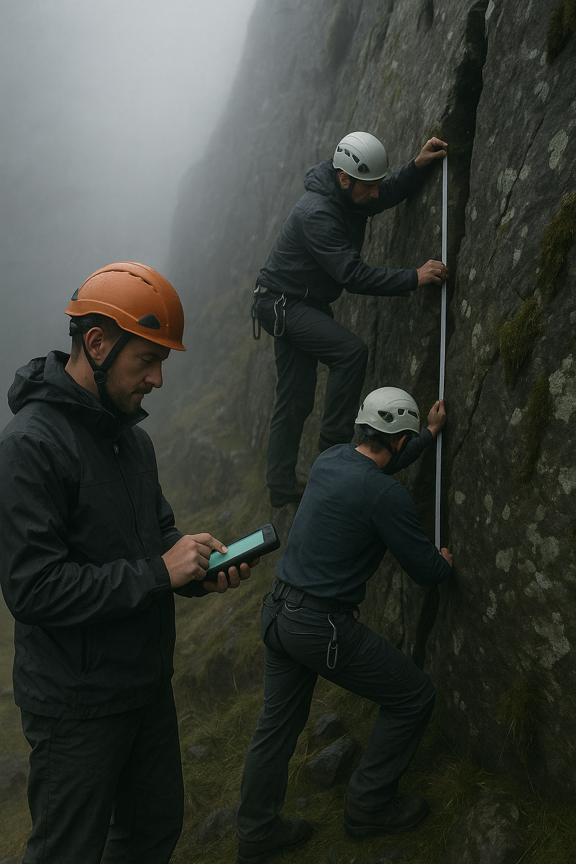**Excerpt — Geotech Report 3.2**  
*Rockfall probability at anchor point: 1 in 380 yrs (pre‑storm), 1 in 60 yrs (post‑storm 2023).*

*WhatsApp — Climbing Club Committee:*  
*Ellie:* “Visual intrusion? It’s a box the colour of lichen.”  
*Tom:* “Sir A’s lichen or ours?”  
*Raj:* “Whose crash pads block more view?”

*Maze moment:* Park geologist confides numbers **massaged down** — “Director hates three‑digit probabilities.” Risk flows uphill; accountability trickles downhill like melt‑water, freezing overnight into black ice nobody owns.

*Cost Sheet Snapshot:* Helicopter provisional already 12 % over; bolt count still zero.

**Weather Station Print‑out** — *Wind > 40 knots 11/14 days.*  
*Red biro annotation:* “Rain angle basically horizontal. Umbrella index: nihil.”

*Field Sketchnote:* Contour lines resemble fingerprints; I wonder whose. Plot route of potential fotpath diversion; looks like signature of guilt.

**Consultant Email** — Visual Impact Analyst  
“Recommend dusk photography; dark hides bulk.”  
*Attachment:* Lightroom preset titled *“Penumbra Positive”*.

*Late‑night voicemail* — Sponsor: “Thumbs‑up on cost if it stays below litigable threshold.” Actuarial tables hum lullaby of plausible deniability.

**Sticky‑note:** “Find owner of landing zone. Rumour: Crown estate? Check Domesday footnote.”

**Morning Podcast** — Park Ranger interview: “A hut halfway up will save lives, but it’s hard to insure serenity.” Download count 14 k.

# Month 3 — “Paper Walls”

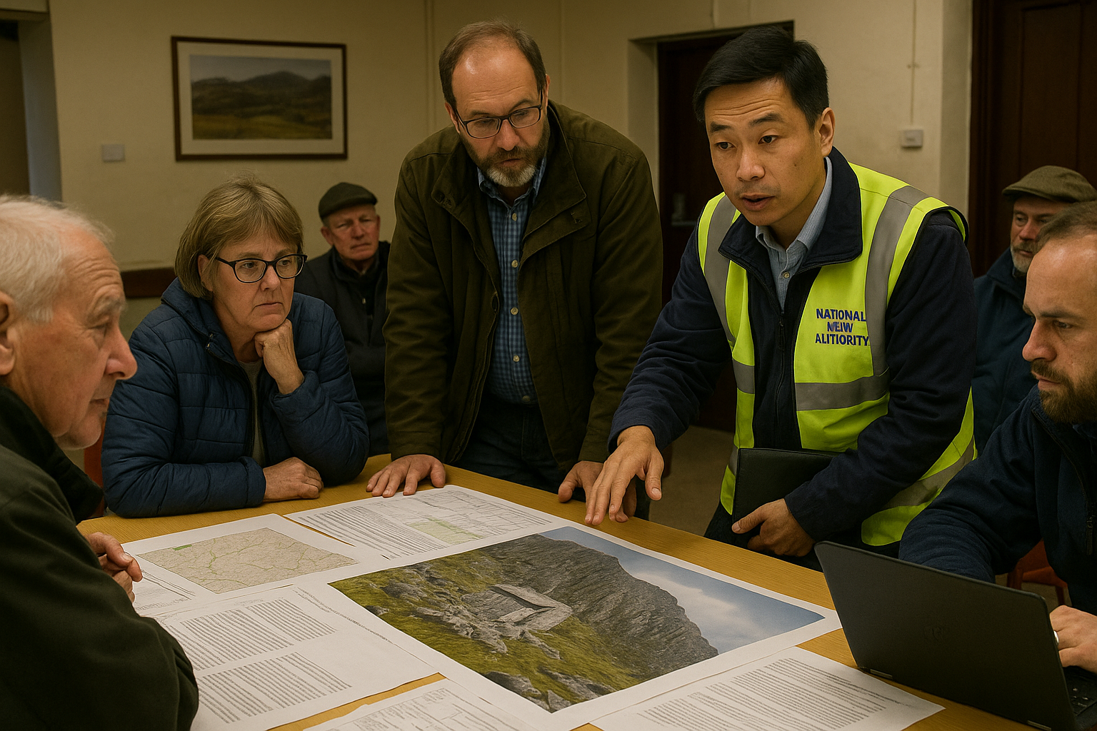

**Minutes — Statutory Consultation, Item 7**  
*Environmental NGO warns of ‘cumulative view‑scape degradation’; NPA counters with utilitarian safety gains.*

*PM Notebook:* The unwritten law resurfaces — *‘A manager’s horizon narrows to what the boss wants to hear.’* Meeting ends commissioning “additional photomontages”—translation: defer battle six weeks.

*Midnight email to self:* *Remember crampons. Also a thesaurus for mitigation.*

**Freedom‑of‑Information Draft** — NGO legal prepping request for “all emails containing *intrusion*.” IT guy: “That’s half your inbox, pal.”

*Action Tracker:* 17 open items, 11 need “cross‑party consensus”; consensus = first party too tired to object. Add caffeine to critical path.

**Coffee‑machine Rumour:** NPA wants QR‑coded trail “explaining heritage *before* shelter exists.” Museum curator grins: “History is a pre‑existing condition.”

*Margin note:* Project famous among those who hate it, invisible to those who need it. Public-awareness asymmetry = 1/∞.

**Private Slack — Legal**  
“Define ‘visual harmony’ for contract.”  
*Reply:* “Whatever shuts the litigant up.”

**Month 4 — “April Promises”**

**Press Release Draft v5** — “A discreet lifesaver perched on England’s high altar of rock.”  
Track‑changes reddened by five stakeholders; ‘discreet’ → ‘near‑invisible’ → ‘contextual’; Legal inserts ‘sympathetic to vernacular geology’. Marketing suggests “an alpine whisper.”

*Evening field note:* Mountain Rescue chief passes flask: “Branding’s nice, but will the door open under rime ice?” Add TODO: rime‑clearance test.

*Slack Poll — Colour Palette:*

* Lakeland Green (38 %)
* Shadow Grey (24 %)
* “Match the sky” (18 %)
* *Stone‑washed silence* (5 %)
* Write‑in: *Invisible Fortitude* (2 %)

I tick “grey”; snow will arbitrate.

**Risk Matrix Snapshot** — “Political interference” amber after Tourism MP tweets selfie in brand‑new Gore‑Tex. Gossip: he borrowed jacket.

*Dream journal:* Shed sprouts legs, walks valley to evade planning; villagers feed it pies. Wakes craving pastry.

**Finance Chat:** “Why does colour debate hit CAPEX?” Because debate = billable minutes; minutes accumulate like snow.

**Radio Snippet** — Shepherd Ben again: “Can of worms for a box of tea.” Listeners perplexed; we know.

*Design Charrette Transcript:* Architect muses about “monastic minimalism.” Sponsor scribbles “cheap?” in margin.

**Month 5 — “Supply Lines & Moral Mazes”**

*Email* — Gear Manufacturer → Sponsor:  
*“Prototype alloy frame ready; void where payment should be.”* Adds ASCII shrug.

*Snippet from cost tracker:* contingency haemorrhaged by path‑restoration. Sir A. shrugs: “Spend public, save private.”

*Internal Slack:* Intern shares photoreal render; NPA Legal responds with camouflage‑netting GIF. Message louder than policy. Reaction: 🔍👀🔥

**Field Memo #11** — Mule‑train feasibility  
*“Equine contractor wants hazard bonus for ‘volatile sheep’.”* Add line item: ovine volatility mitigation.

*Maze echo:* Compliance pre‑screens jokes. Humour singled‑point‑of‑failure.

**CFO Text (encrypted):** “Risk transfer clause looks leaky — plug it before year‑end audit.”  
*Unencrypted follow‑up:* “Preferably yesterday.”

*Supplier Call:* Manufacturer admits alloy yield curve wrong; markets boutique patina as *feature*. I annotate lipstick‑on‑pig; pig squeals in ledger.

**Watercooler whisper:** “Park may ask solar panels — ‘carbon‑positive hut’.” Adds 40 kg, offends helicopter. File under *green guilt*.

Budget graph dips below red line; morale dips below caffeine threshold; both rebound after doughnuts.

**Risk Register Addition:** “Supply‑chain reputational contagion” probability medium, impact existential.

**Month 6 — “The Veto Season”**

*Diary (5 Jun):* Sir A. flashes veto after NGO blog “Crag or Crag Mall?” garners 5 k shares; trending hashtag #SaveTheSkyline.

**Climbing Club Bulletin**  
*“Members asked to write polite letters; no emojis. Bonus points for haiku.”*

*NPA Memo:* Proposes renaming project “Safety Refuge” to neuter click‑bait. Comms says *Refuge* polls badly with Mail readership, evokes asylum narrative. Alternative: “Weather‑Safe Cache.”

*Mood check:* Staff CC Legal on lunch orders; Legal sets autoreply: “Enjoying sandwich, liable to nothing.”

**Covert Note — Park Planner:** “If veto exercised, pivot to ‘temporary installation’; permits simpler. Remember Grenfell lessons.”

*Evening walk:* Pace helicopter pad with stones, reciting budget codes like rosary beads. Shepherd Ben waves: “Counting stones again?”

**Unsent Draft to Sir A.:** “Veto erodes goodwill faster than weather erodes fellside.” (Saved, unsent. Courage on back‑order.)

*Stakeholder Heatmap:* Veto glows crimson. PR team recommends “pre‑emptive success story.” Build story before shed.

**Month 7 — “Iron in the Fog”**

Delivery dockets: two mules, four porters, eight aluminium ribs arrive; porters request selfies. Helicopter pilot demands hazard pay “for flying through pea soup + influencer debris.”

*SMS — Mountain Rescue → PM:* “Storm Friday. Fly panels tomorrow or stall a month.” Three lightning emojis.

*Decision Log (red‑ink):* Flew them. Rotor wash uproots rowan; NGO posts “Cragpocalypse” before rotors cool; hashtag trends midday.

*Slack DM — Me → Sponsor:* “Reputational risk spiking.”  
*Sponsor:* “Risk is just PR spelled differently.”  
*I reply:* “Dictionary says otherwise.” No response.

**Incident Report 7/14** — Panel drops 20 m, no injuries. Classification: Near‑miss (translation: bury pre‑Monday). Attach GIF, bury deeper.

Inbox 02:00 — *“Amended Inter‑Party Liability Grid, v12f.”* Visualise grid overlaying boulders like corporate constellations. Stars spell *CYA*.

**Helicopter Invoice:** 1.35× contract plus ‘heroic surcharge’, plus ‘viral content surcharge’. Procurement learns new lexicon.

*Voice Note — Drone filmmaker:* requests access to film “beauty of logistics.” Denied; beauty embargoed.

**Month 8 — “Assemblage”**

*Field Note (14 Aug):* Frame rises like Meccano reliquary. Climbing Club festoons retired slings like prayer flags; Park architect mutters “vernacular clutter,” secretly photographs for lecture.

**Hazard Memo** — Rockfall sensor false‑positive rallies path‑crew; foreman: “Crag sneezed.” Add tissue budget line.

Tourism Board slide: *“Iconic Safety Heritage — +7 % overnight stays.”* History written before paint dries, footnote references future podcast series.

*Personal aside:* Dream screws backing out in dark; wake to tighten real ones. Gorilla‑glue sponsor approaches.

**Crew morale poll:** Avg 3.8/5; gripe “no signal to stream football.” Add satellite hotspot; battery fried by hail; crew 3.0/5.

Park Ecologist laser‑maps rare moss; shift footing 0.7 m west. Engineer laughs, measures, shrugs, orders longer beam.

**Email — Architect → Me:** “Stone cladding idea resurrected. Sir A. wants mini‑Bothy chic.” Adds tonne; helicopter swears. Thread ends in ellipsis.

**Influencer Collab Pitch:** “Sunrise yoga on shelter roof.” Declined; roof 1.2 m², load rating tears.

*Equipment Tracker:* missing torque wrench; found as selfie stick.

**Month 9 — “Inspections & Introspections”**

Quote — Park Inspector: “It blends, if you squint.”  
NGO retort: “We refuse to squint.”  
Local podcast coins term “Squint Factor.” Merch on Etsy.

Risk Register: add *Public Petition (change.org)* — probability low, impact career‑ending. Add mitigation: “bake sale diplomacy.”

PM reflection: Maze tightens; success = silence, failure = headlines. Choose manageable scandal.

*Maze note:* Managers practise plausible‑denial tai‑chi — leaning, never stepping. HR offers mindfulness workshop.

**Audit Trail:** 47 revisions for drawing C. Auditor: “Version control exemplary or desperate.” We choose *agile* synonym.

Evening: Tap door latch ten times — superstition: metal remembers attention; whisper “hold, hold.”

*Stakeholder Map Revision:* Arrows resemble vascular system; I diagnose hypertension.

**Training Slide — Rescue Team:** “Door mechanism rated to −15 °C. Real test: January.” Silence in room.

**Month 10 — “Door Opens”**

Launch Day (22 Oct): sleet. First visitors — soaked Glaswegians; ledger note: *“Tea tastes of aluminium but we live.”* Add brew‑kit upgrade to phase 2.

**Tweet — @NPAuthority:** *“Collaboration is the highest foothold.”* — 452 likes, one lichen emoji, three trolls, retweeted by Tourism MP.

Final budget to Sir A.: 1.7 % over. Reply: “Cheaper than lawsuit.” CFO breathes in, not out.

**Maintenance Handover Sheet:** Mountain Rescue accepts spare hinges, two tins matching paint, “moral custody,” and unresolved solar‑panel dream.

Quiet: wind combs joists; structure hums like generator of relief. I breathe; phone buzzes — email subject *“Phase II concept: bivvy pods.”* Close phone.

*Press Clipping:* Local paper: “Shelter or Sore?” Photo: tiny box dwarfed by cliff; click‑bait moderate; ad revenue moderate.

Post‑Project Note: Sir A. wants postcard‑size bronze plaque; NGO agrees if patinated. Smithies booked. Inscription drafted: *“Safety, Stewardship, Storm.”* Marketing suggests adding QR code.

*Project Manager epilogue:* I close diary with mud on boots and perhaps on conscience. Door opens — occasionally slams against gale, exactly as promised. Crag indifferent; maybe that’s success. I leave a tin of biscuits labelled *For Future Wanderers*. Wonder if crag will eat tin first._